Nature, 401, 37-38, 1999
Brief communications, Physiology

Warm feet promote the rapid onset of sleep

Even healthy people occasionally have difficulty falling asleep. Psychological relaxation techniques, hot baths, soothing infusions of plant extracts, melatonin and conventional hypnotics are all invoked in the search for a good night’s sleep. Here we show that the degree of dilation of blood vessels in the skin of the hands and feet, which increases heat loss at these extremities, is the best physiological predictor for the rapid onset of sleep. Our findings provide further insight into the thermoregulatory cascade of events that precede the initiation of sleep¹.
Our analysis combines data from two intervention studies designed to induce phase shifts in the circadian pacemaker^{2,3}. Healthy young men were given melatonin, bright light, or both, in the evening (n=8), or a large carbohydrate-rich meal in either the morning or the evening (n=10). These manipulations had different thermoregulatory effects and so gave a broad variance, enabling us to extract the best predictor variables for the latency of sleep onset.
Subjects lay in bed under controlled conditions (lighting less than 8 lux; 22 °C), taking small snacks of constant caloric value every hour during wakefulness. The latency of sleep onset was defined as the time between lights out (24:00) and the first occurrence of stage 2 in the sleep EEG recordings. Heart rate, core body temperature (rectal) and proximal (combined infraclavicular, thigh, stomach, forehead) and distal (combined hands and feet) skin temperatures were continuously measured⁴ (and later collapsed into 30-min bins). Sleepiness was rated² every 30 min and saliva was collected for melatonin assay⁵. We calculated the distal–proximal temperature gradient (DPG), a measure of blood flow in distal skin regions (efficiently regulated by artereovenous anastomoses)⁶ that provides an indirect index of distal heat loss.
By using a multiple regression model for repeated measures, with the latency of sleep onset as the dependent variable (n=18 subjects, 144 data points; between-subjects differences taken into account), we found the highest correlation with the DPG averaged over the three data points between 22:30 and 24:00 (r=-0.47, P<0.0001). Thus, the greater the distal vasodilation in the late evening, the shorter was the time taken to fall asleep. We found that correlations were weaker with subjective sleepiness ratings (r=-0.33, P<0.0001), core body temperature (r=0.26, P<0.005), melatonin (r=-0.15, n.s.; after excluding the melatonin intervention data), rate of change of core body temperature (r=-0.05, n.s.) and heart rate (r=0.05, n.s.).
In a backward stepwise regression analysis among all predictor variables, only DPG contributed significantly to the model; that is, vasodilation of distal skin regions was the best predictor of the body’s readiness for sleep (Fig. 1). Because interventions such as light or large carbohydrate-rich meals differentially manipulated the independent variables, the effect on the dependent variable showed that the link between distal vasodilation and the ability to fall asleep is functional, not just correlative.
The circadian clock prepares the thermoregulatory system for vasodilation to begin in the early evening as sleepiness increases, followed by a drop in core body temperature. Even lying down increases sleepiness by redistributing heat in the body from the core to the periphery⁷. Turning out the light is a complex cognitive and physiological signal that also leads to vasodilation⁴. There is a tight correlation between the timing of the endogenous increase in melatonin in the evening and vasodilation, an effect that is mimicked by pharmacological doses of melatonin^{4,7}. Before bedtime, then, many overlapping events orchestrate the thermoregulatory overture.
We would predict that classical hypnotics⁸ and other sleep-inducing aids all cause dilation of distal blood vessels and heat loss before the onset of sleep. A hot-water bottle at the feet, while not acting on mechanisms in the central nervous system that underly the regulation of sleep, can rapidly induce vasodilation. The resulting heat loss is most efficient when the ambient temperature is cool⁹. Some sleep disorders (particularly those associated with ageing and somatic illness¹⁰) may be secondary to an inability to vasodilate and prepare the body for sleep.

Figure 1
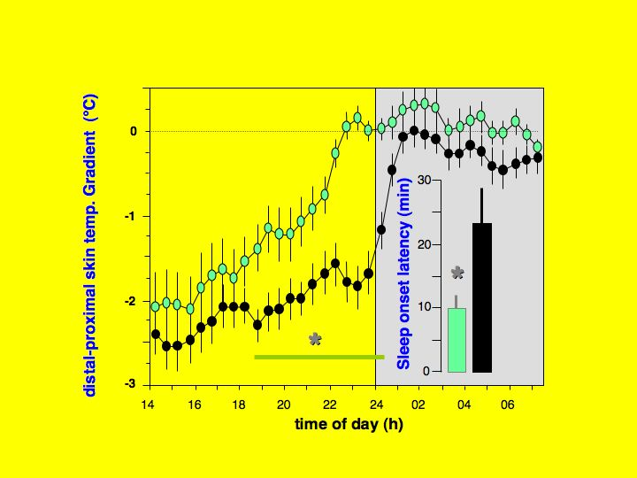

Figure 1
Time course of the distal–proximal skin-temperature gradient (DPG). The gradient is shown from 14:00 to 7:30 for observations with the most negative DPG values between 22:30 and 24:00 (large vasoconstriction before lights out at 24:00; black symbols), compared with the time course of the most positive DPG values (large vasodilation before lights out; green symbols) (mean±s.e.m., n=18; asterisk indicates significant differences between data points; P<0.05). The shaded area indicates the lights-out period. These two extreme patterns were selected after the mean of the three DPG values between 22:30 and lights out at 24:00 had been rank ordered out of 8 observations for each subject. Sleep onset latency (inset) is significantly shorter when subjects were most vasodilated (green bar) before lights out (asterisk indicates significant differences; paired t-test, P<0.001).

Kurt Kräuchi, Christian Cajochen,
Esther Werth, Anna Wirz-Justice

Chronobiology and Sleep Laboratory,
Psychiatric University Clinic,
Wilhelm Klein-Strasse 27, 4025 Basel, Switzerland
e-mail: kurt.kraeuchi@upkbs.ch

1. Campbell, S. S. & Broughton, R. J. Chronobiol. Int.11,126–131 (1994).
2. Cajochen, C., Kräuchi, K., Danilenko, K. V. & Wirz-Justice, A. J. Sleep Res.7,145–157 (1998).
3. Wirz-Justice, A. et al.J. Sleep Res.7(suppl. 2), 308 (1998).
4. Kräuchi, K., Cajochen, C., Möri, D., Hetsch, C. & Wirz-Justice, A. Am. J. Physiol.272,R1178–R1188 (1997).
5. Weber, J. M., Unger, I., Wirz-Justice, A. & Schwander, J. C.
J. Sleep Res.7(suppl.2),302 (1998).
6. Rubinstein, E. H. & Sessler, D. I. Anesthesiology73,541–545 (1990).
7. Kräuchi, K., Cajochen, C. & Wirz-Justice, A. in Circadian Clocks and Entrainment(eds Honma, K. I. & Honma, S.) 131–146 (Hokkaido Univ. Press, Sapporo, (1998).
8. Gilbert, S. S., van den Heuvel, C. J. & Dawson, D. J. Physiol. (Lond.)514,905–914 (1999).
9. Aschoff, J. Wien. Med. Woch.19/20,404–409 (1958).
10. Foley, D. J. et al.Sleep18,425–432 (1995).

